

**DC-DC BOOST CONVERTOR**

BTECH PROJECT

**Bachelors in Engineering**

#### By Chandan kumar

Supervisor

#### DR. Dlip dey

**Department Electrical engineering  
Haldia institute of technology**

#### 2020-2021

**Chapter No. Title Page no.**

**List of figures i**

List of tables ii

Abstract 1

Chapter 1: Introduction 2

Chapter 2: Literature Review 3

* 1. Survey
  2. Research Gap

Chapter 3: Project Description 5

* 1. Problem Definition
  2. Steps Involved
  3. Block Diagram
  4. Component Description
     1. Components Used
     2. Components Description
  5. Working of the project
  6. Calculation

**Chapter 4: Implementation 14**

4.1 Hardware

4.3 Software

4.3 Flowchart

|  |  |  |  |
| --- | --- | --- | --- |
| **Chapter** | **5:** | **Result** | **18** |
| **Chapter** | **6:** | **Conclusion** | **21** |
|  |  | **References** | **22** |
|  |  | **Datasheets** | **23** |

|  |  |  |
| --- | --- | --- |
|  | **List of Figures** |  |
| **Figure No.** | **Title** | **Page No.** |
| Fig. 3.3.1 | Block diagram of general DC-DC boost convertor | 5 |
| Fig. 3.4.1 | IC 555 pinout | 7 |
| Fig. 3.4.2 | Pinout of 1000uf capacitor | 7 |
| Fig. 3.4.3 | Symbol of 1nf capacitor | 8 |
| Fig. 3.4.4 | Pinout of Mosfet | 8 |
| Fig. 3.4.5 | Actual photo of Schottky Diode( STPS2045C) | 9 |
| Fig. 3.4.6 | Potentiometer | 9 |
| Fig. 3.4.7 | Coiled Inductor | 10 |
| Fig. 3.4.8. | LM7805 Pinout | 10 |
| Fig. 3.5.1 | Closed switch mode | 11 |
| Fig. 3.5.2 | Open switch mode | 12 |
| Fig. 4.1.1 | Implementation on GPB | 15 |
| Fig. 4.1.2 | Implementation on PCB | 15 |
| Fig. 4.2.1 | Top View Of PCB | 16 |
| Fig. 4.2.2 | Bottom View Of PCB | 16 |
| Fig. 4.3.1  Fig. 4.3.2 | Flowchart of working Flowchart of process | 17  17 |
| Fig. 5.1 | Proteus simulation | 18 |
| Fig. 5.2 | Output waveform of first IC 555 | 19 |
| Fig. 5.3 | Output waveform of second IC 555 | 19 |
| Fig. 5.4 | Result on GPB | 19 |
| Fig. 5.5 | Final result on PCB | 20 |

i

|  |  |  |
| --- | --- | --- |
|  | **List of Table** |  |
| **Table No.** | **Title** | **Page No.** |
| Table 3.4.1 | Components used | 6 |
| Table 3.6.1 | Calculations | 13 |

ii

## Abstract

The switching mode power supply market is flourishing quickly in today’s world. Design engineers aren’t always supplied with the desired amount of voltage they need in order to make their design function properly. Adding an extra voltage supply to a design is not always cost efficient. This is proposed to provide the designer with a method of boosting DC voltage , by using a boost converter designed specifically for this task. By using boost converters not only the cost for making the circuits is reduced, the circuit will be more proficient by using the DC DC boost converters. All aims, calculations, tests, data and conclusions have been documented within this report.

# Introduction

Power for the boost converter can come from any suitable DC sources, such as DC generators, batteries, solar panels and rectifiers. The method that changes one DC voltage to a different DC voltage is called DC to DC conversion. Generally, a boost converter is a DC to DC converter with an output voltage greater than the source voltage. It is sometimes called a step-up converter since it “steps up” the source voltage.

In many technical applications, it is required to convert a set voltage DC source into a variable- voltage DC output. A DC-DC switching converter converts voltage directly from DC to DC and is simply known as a DC Converter. A DC converter is equivalent to an AC transformer with a continuously variable turns ratio. It can be used to step down or step up a DC voltage source, as a transformer. DC converters are widely used for traction motor control in electric automobiles, trolley cars, marine hoists, forklifts trucks, and mine haulers. They provide high efficiency, good acceleration control and fast dynamic response. They can be used in regenerative braking of DC motors to return energy back into the supply. This attribute results in energy savings for transportation systems with frequent steps. DC converters are used in DC voltage regulators; and also are used, with an inductor in conjunction, to generate a DC current source, specifically for the current source inverter.

### 2.1 Research Gap

1.In reference to the first paper, it is on a multilevel converter which has multiple outputs and the conversion rises from 50V to 300V. Whereas, on the other hand, our proposed converter is bound to work in a range which is compatible with the low-voltage devices[1].

2..In reference to the second paper mentions a multi input-multi output converter which has outputs with different dc voltage levels, the conversion rate it showed was very low as it went from 35V to 40V and 80V, even though the accessories they used were much more advanced and outnumbered our model[2].

Thus, we have created a model which is not only cost efficient but also provides a similar conversion efficiency to the papers mentioned above.

# Chapter 3

**Project Description**

This chapter briefly describes the problem statement , steps involved while doing the project and the whole working of the project.

### Problem Statement

Circuits powered by batteries, such as laptops and mobile phones. All of these electronic devices mostly have many sub-circuits, and all of that requires a certain voltage level other than that supplied by the battery. The voltage of the battery will reduce as its stored energy is nearly depleted, keeping it from outputting a constant voltage level. Multiple control voltage can be generated from a single battery voltage and this method was offered by DC to DC converters without using multiple batteries for different components of the equipment.

### Steps involved

Steps followed for the implementation of DC-DC BOOST CONVERTORS using IC 555 are given below:

* + 1. A circuit diagram was first created and analyzed for the given problem statement.
    2. Simulation of this circuit diagram was made and run using PROTEUS software.
    3. Faults in this circuit diagram were identified and addressed accordingly based on the simulation results.
    4. The given circuit diagram was implemented on a breadboard and temporary connections between the components were made.
    5. Power supply was given to the circuit and the results were noted.
    6. PCB design of the circuit was made using EAGLE software.
    7. PCB was fabricated and all the components were mounted and the circuit was implemented on a PCB.

### Block Diagram of proposed Project

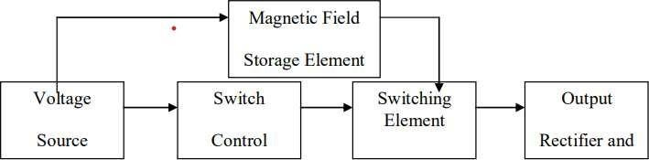

**Fig. 3.3.1 Block diagram of general DC-DC boost convertor**

The voltage source provides the input DC voltage to the switch control, and also to the magnetic field storage element. The block which contains switch control directs the action of the switching element, whereas the output rectifier and filter deliver an acceptable DC voltage to the output.

* Voltage Source - Input DC voltage source to power on the circuit ( 6V To 12V DC)
* Switching Element - Mosfet used to short circuit the inductor to the gnd to (sudden change in current build up it maganit field )
* Magnetic Field Storage Element - Inductor is used as Magnetic Field Storage Element
* Switch Control - NE555
* Output & Rectifier - Diode is used dump the voltage change across inductor into output capacitor (for setting up the output v)

### Component Description:

**3.4.1. Components Used:**

**Table 3.4.1 Components Used**

|  |  |  |  |
| --- | --- | --- | --- |
| **Sr.**  **No.** | **Name of Components** | **Specification** | **Quantity** |
| 1 | Integrated circuit | IC 555 | 2 |
| 2 | Capacitor | 1000uF | 1 |
| 3 | Capacitors | 1nF | 2 |
| 4 | Mosfet | IRF540N or NCE8295A | 1 |
| 5 | Potentiometer | 10k | 1 |
| 6 | Diode | STPS2045C | 1 |
| 7 | Inductor | 52uH | 1 |
| 8 | Resistors | 47kΩ, 1kΩ, 10kΩ, 22Ω | 1,2,5,1 |
| 9 | Capacitors | 100nF | 4 |
| 10 | Capacitor | 470uF | 1 |
| 11 | Voltage Regulator | LM7805 | 1 |
| 12 | Comparator | LM358A | 1 |

### Description of Components

**3.4.2.1 IC 555:**

IC 555 timer is a one of the most widely used IC in electronics and is used in various electronic circuits for its robust and stable properties. It works as a square-waveform generator with duty cycle varying from 50% to 100%, Oscillator and can also provide time delay in circuits. The 555 timer got its name from the three 5k ohm resistors connected in a voltage-divider pattern which is shown in the figure below. A simplified diagram of the internal circuit is given below for better understanding as the full internal circuit consists of over more than 16 resistors, 20 transistors, 2 diodes, a flip-flop and many other circuit components.

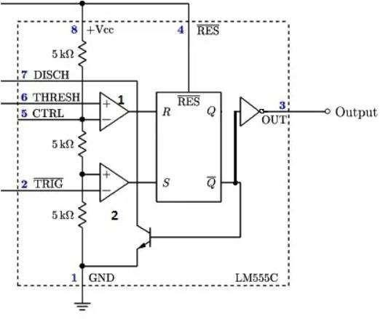

### Capacitor:

**Fig. 3.4.1 IC 555 pinout**

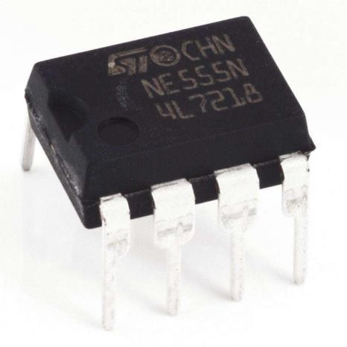

1. **100uf:**

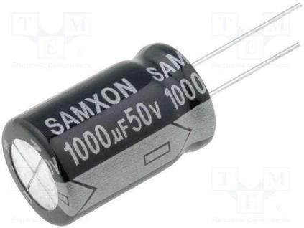This **1000uF 50V** capacitor is a good quality radial polarized Electrolytic capacitor. Electrolytic capacitors are widely used in switched-mode power supplies, **DC-DC** converters, and power supplies. This capacitor has a long life, low leakage current, and wide operating range.

**Fig. 3.4.2 Pinout of 1000uf capacitor**

##### Ceramic Capacitor:

A ceramic capacitor is a fixed-value capacitor where the ceramic material acts as the dielectric. It is constructed of two or more alternating layers of ceramic and a metal layer acting as the electrodes. The composition of the ceramic material defines the electrical behavior and therefore applications.

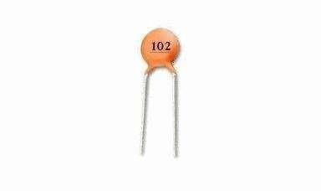Specifications:

* + Capacitance 1000pF
  + Tolerance(%) ±10
  + Voltage (V) 50
  + Operating Temperature Range -55°C to 125°C
  + Mounting Type :Through Hole

### Mosfet:

**Fig. 3.4.3 Symbol of 1nf capacitor**

The working principle of MOSFET is very simple and it includes three terminals namely source, drain and gate . Once we apply the signal at the transistor’s Gate terminal, then both the terminals like drain and gate will be shorted. Whenever the Drain and the Gate gets shorted, then only we can get the preferred results, or else it will generate unnecessary outputs.

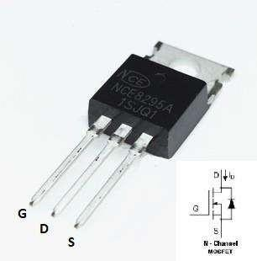

**Fig. 3.4.4 Pinout of Mosfet**

### Schottky Diode( STPS2045C):

Dual center tap Schottky rectifier suited for switch mode power supply and high frequency DC to DC converters. Packaged either in TO-220AB, TO-220FPAB, or D²PAK, this device is especially intended for use in low voltage, high frequency inverters, free wheeling and polarity protection applications

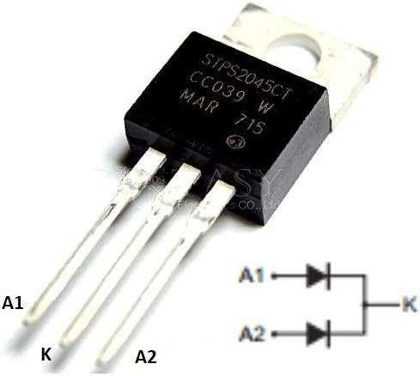

**Fig. 3.4.5 Actual photo of Schottky Diode( STPS2045C)**

### Potentiometer:

A potentiometer (also known as a pot or potmeter) is defined as a 3 terminal variable resistor in which the resistance is manually varied to control the flow of electric current. A potentiometer acts as an adjustable voltage divider.A potentiometer is a passive electronic component. Potentiometers work by varying the position of a sliding contact across a uniform resistance. In a potentiometer, the entire input voltage is applied across the whole length of the resistor, and the output voltage is the voltage drop between the fixed and sliding contact . Fig 3.5 Potentiometer. Potentiometer is use to vary the duty cycle, to keep the the output voltage constant.

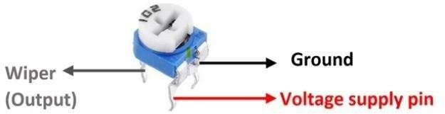

**Fig. 3.4.6. Potentiometer**

### Inductor:

An inductor is a coil of wire that stores energy in the form of a magnetic field. The magnetic field depends on current flowing to "store energy."

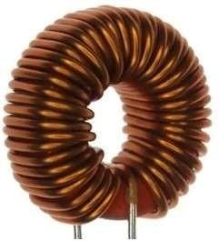If the current stops, the magnetic field collapses and creates a spark in the device that is opening the circuit.

### 3.4.2.7 LM7805:

**Fig. 3.4.7. Coiled Inductor**

The LM340 and LM7805 Family monolithic 3-terminal positive voltage regulators employ internal current limiting, thermal shutdown and safe-area compensation, making them essentially indestructible. If adequate heat sinking is provided, they can deliver over 1.5-A output current. They are intended as fixed voltage regulators in a wide range of applications including local (on-card) regulation for elimination of noise and distribution problems associated with single-point regulation. In addition to use as fixed voltage regulators, these devices can be used with external components to obtain adjustable output voltages and currents.

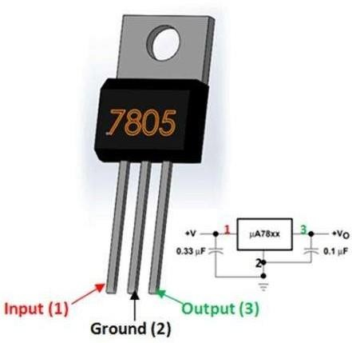

**Fig.3.4.8. LM7805 Pinout**

### Working of proposed project

The boost converter is used to increase the output voltage by reducing the current, this is achieved by storing energy in an inductor and since the energy in an inductor cannot change instantly therefore, it starts storing the energy in its magnetic field. Current across the inductor is given by V= Ldi/dt. An inductor is connected in series with the voltage source to constantly turn on and off a circuit. A switch is connected in parallel to the voltage source and inductor for achieving fast switching we utilize a MOSFET along with a MOSFET driver. The circuit is connected to a load and a capacitor in parallel to it. In order to stop the current flowing backwards from the capacitor, a diode is used between the capacitor and the MOSFET.

The inductor tries to resist change in the current to provide a constant input current and hence the Boost converter acts as a constant current input source, while the load acts as the constant voltage source.The N- channel MOSFET is controlled by a PWM signal, we have used IC 555 timer to provide the output to the MOSFET. The capacitor is used to store the charge and provide a constant output to the load. The circuit works in 2 stages, in the 1st stage, the switch is turned on and in the 2nd stage, the switch is in the off stage.

**Stage 1: Switch is on: Charging mode**

In this condition the MOSFET switch is turned on. The MOSFET we have used is a N-channel IRFZ44N MOSFET, with its gate pin connected to the pin 3 of the IC555 timer. When the switch is in ON state, it completes the circuit across the inductor and the voltage is applied across it which results in a magnetic field around it. Since it offers a very low resistance path, all the voltage flows through the switch and goes back to the supply as marked by the red line in the figure below.

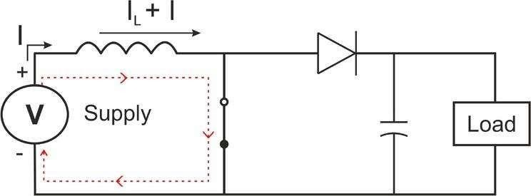

**Fig 3.5.1 Closed switch mode**

The capacitor which was previously charged during the last on stage tries to discharge itself from the MOSFET and to stop it, we use a diode in order to stop the charge from capacitor flowing in the reverse direction.

**Stage 2: Switch is off: Discharging mode**

When the switch is in the off state, the inductor’s charging path is not completed, hence the polarity of the inductor is reversed and the magnetic field around it collapses as a result a voltage surge is generated which passes through the diode and charges the capacitor. The cumulative energy from the inductor and source is used to charge the capacitor as well as runs across the load.

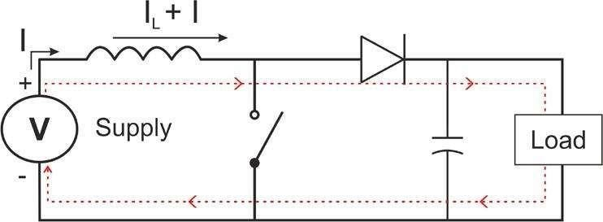

**Fig 3.5.2 Open switch mode**

### Calculations

**Table 3.6.1 Calculations**

|  |  |
| --- | --- |
| load | = 40Ω |
| Input voltage without load | = 12.1V |
| Input voltage with Load | = 11.9V |
| Output voltage without load | = 30.3V |
| Output voltage with load | = 29.71V |
| Input current without load | = 0.117A |
| Input current with load | = 2.063A |
| Output current with load | = 0.71A |
| Input power | =Input Voltage(with load)×Input current(with load)  =11.9V× 2.063A  = 24.54 W |
| Output power | =Output current(with load)×Output Voltage(with load)  =29.71V × 0.71A  =21.094 W |
| Efficiency% | = Output Power × 100 Input Power  = 21.094 × 100  24.54  = 85.95% |

# Chapter 4

### Implementation

#### Hardware:

This section describes the pinout of the both the IC’s and the mosfet:

#### For IC 555(1st):

The IC is connected in the circuit as follows:

* + - Pin 1 of the IC is connected to the ground.
    - Pin 2 and 6 of the IC are connected to the 1nf capacitor.
    - Pin 3 which is output pin is connected to 2nd and 4th pin of second IC which is input to the second IC.
    - Pin 7 is connected to resistors.
    - Pin 8 is connected to the Vcc(input voltage).

#### For IC 555(2nd):

The second is connected in the circuit as follows:

* + - Pin 1 of the IC is connected to the ground.
    - Pin 6 and 7 of the IC are connected to the 1nf capacitor.
    - Pin 3 is connected to the gate of the mosfet and the resistor of 10kΩ.
    - Pin 5 of the IC is connected to the output of the LM358.
    - Pin 8 is connected to the Vcc(input voltage).

#### For Mosfet:

The mosfet is connected in the circuit as follows:

* + - Gate of Mosfet is connected to the output of the second IC.
    - Drain of the Mosfet is connected to the inductor.
    - Source of the Mosfet is grounded.

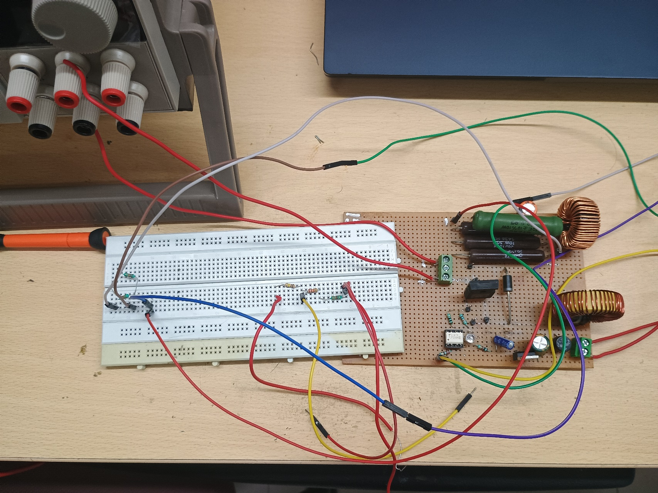

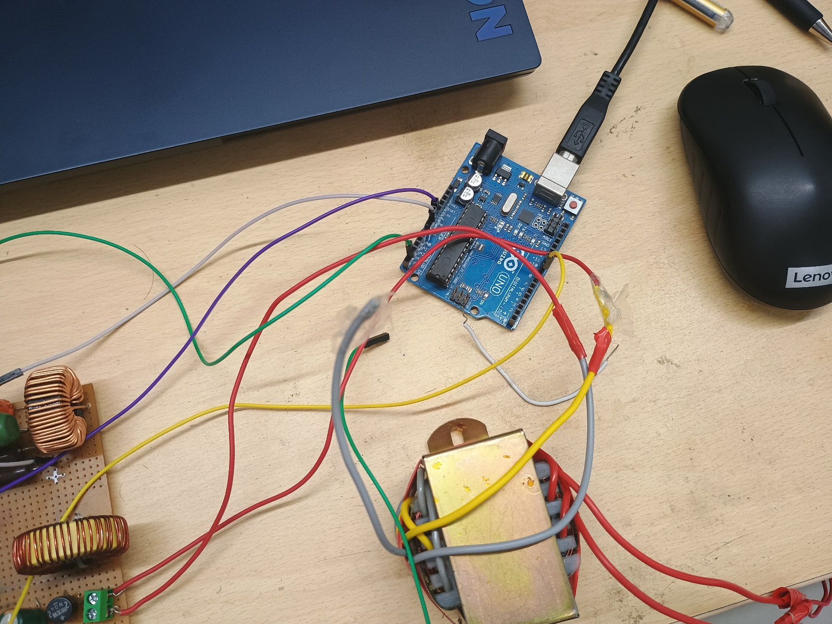

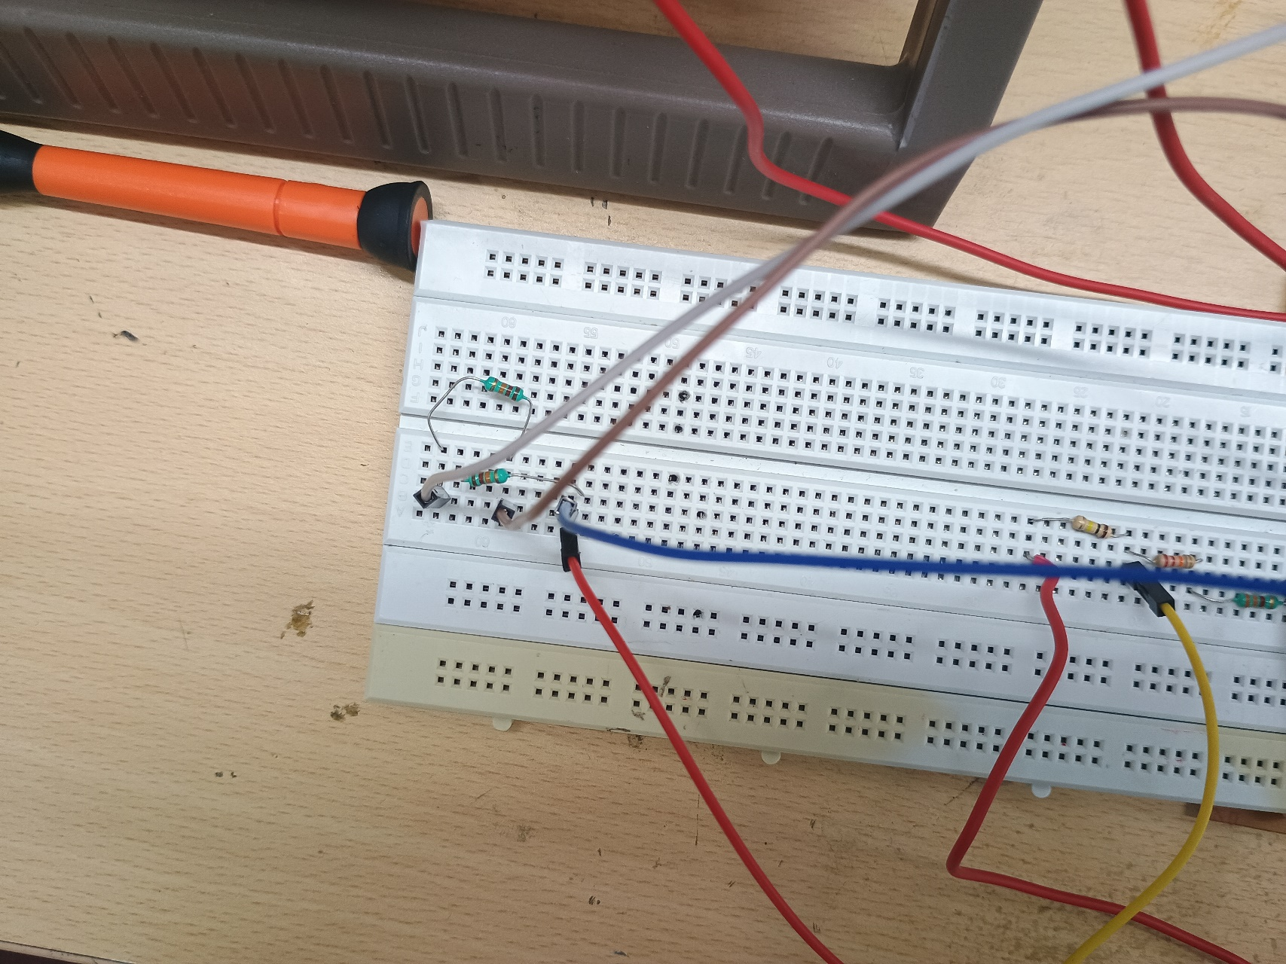

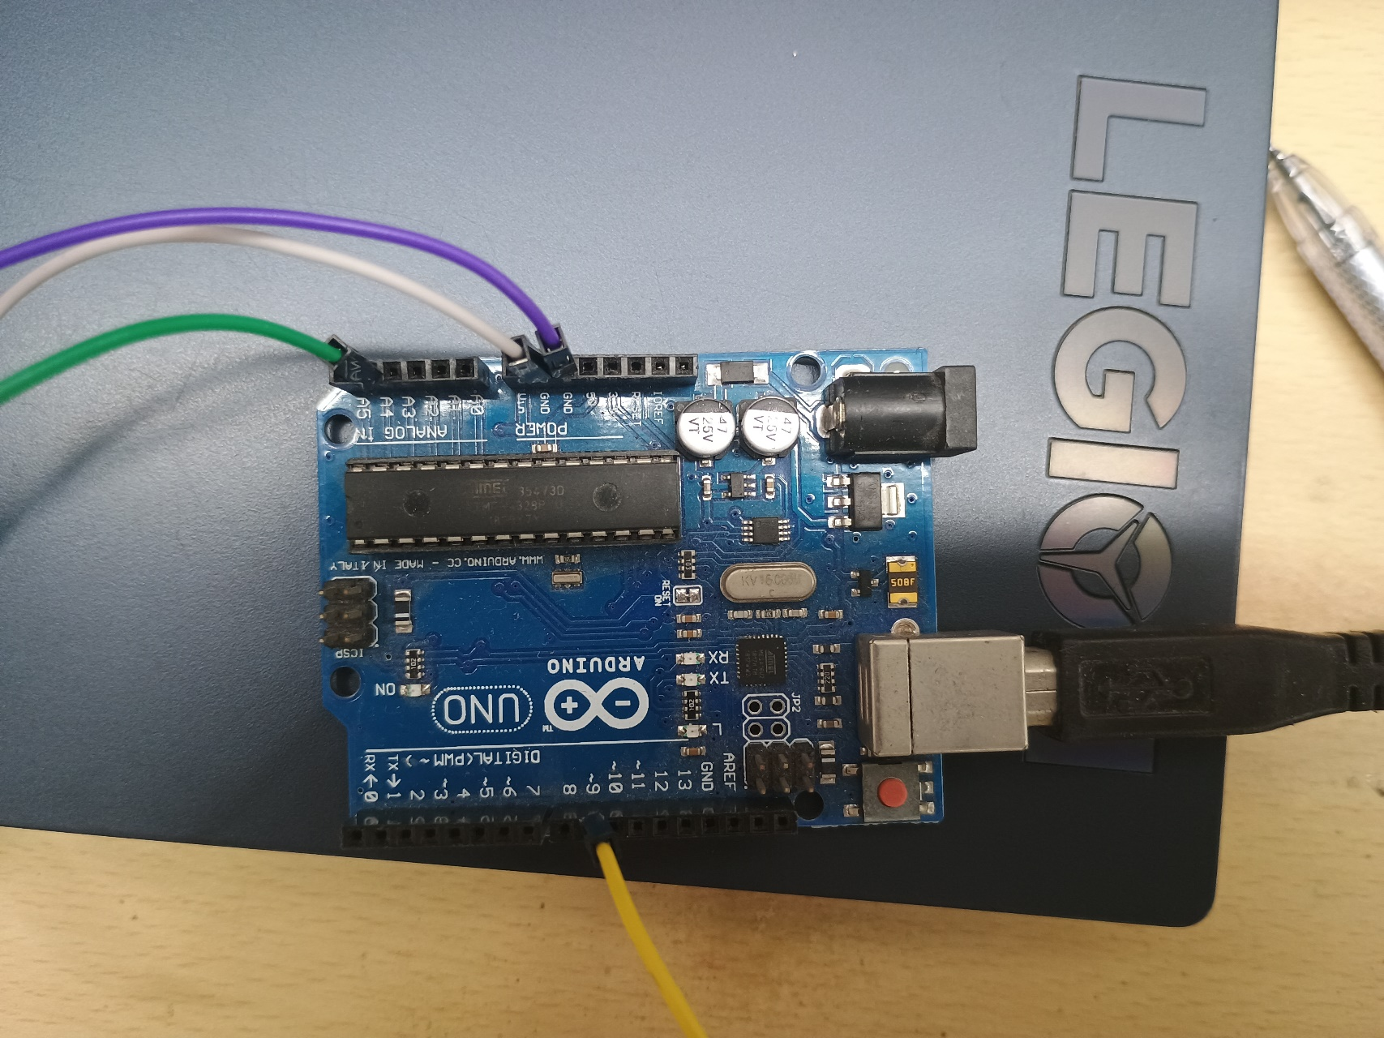

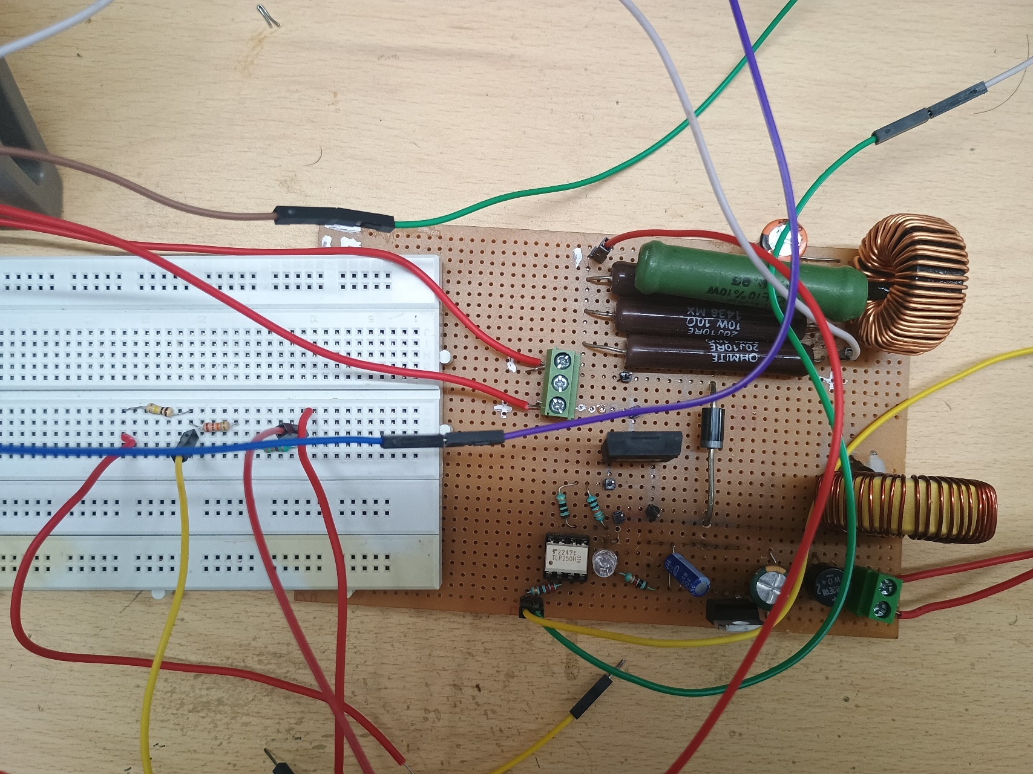

### Datasheets

**NE555**:https://[www.ti.com/cn/lit/ds/symlink/ne555.pdf?ts=1666974810884&ref_url=https%253A%252](http://www.ti.com/cn/lit/ds/symlink/ne555.pdf?ts=1666974810884&ref_url=https%253A%252) F%252Fwww.lcsc.com%252F

**LM358:** https://datasheet.lcsc.com/lcsc/1811100911_onsemi-LM358DR2G-_C7950.pdf

**STPS2045C:** Power Schottky rectifier (lcsc.com)

**NCE8295A:** Microsoft Word - NCE8295A data sheet.doc (lcsc.com)

**Voltage Regulator LM7805 5V:** LM340, LM340A and LM7805 Family Wide VIN 1.5-A Fixed Voltage Regulators datasheet (Rev. L) (ti.com)

**SS34:** 1912111437_Slkor-SLKORMICRO-Elec--SS34_C408258.pdf (lcsc.com)

**IRFZ44N:** DATASHEET SEARCH SITE | WWW.ALLDATASHEET.COM (lcsc.com)

**LM7805**:https://[www.alldatasheet.com/view.jsp?Searchword=Lm7805%20datasheet&gclid=Cj0KCQjwnv](http://www.alldatasheet.com/view.jsp?Searchword=Lm7805%20datasheet&gclid=Cj0KCQjwnv) OaBhDTARIsAJf8eVPchHM8aVaRUFURjSzhWI5UxhK5572aCSsb8BzjMLHBHFV- dJwuVC0aAi2rEALw_ wcB